Flora Sense (Plant Care & Detection System)
- Project Overview
The Plant Care & Detection System (Flora Sense) is a web-based application designed to help users identify plants and understand their characteristics, benefits, risks, and suitability before buying, growing, or using them.
The application allows users to upload or capture a plant image using a mobile camera. The uploaded image is sent to the external Pl@ntNet API for plant identification, which returns the predicted plant name and confidence score. The system then retrieves the corresponding plant information from its database and presents the details to the user.
The application provides information such as plant benefits, medicinal uses, toxicity risks, pet safety, and indoor or outdoor suitability. It also enables users to explore plants, save favorite plants, view previous identification records, and manage their profiles.
Flora-Sense also includes an administrative module for managing users and plant information, monitoring application statistics, and exporting data. Overall, the system aims to make plant discovery more accessible and help users make informed decisions about plant selection and care.

- Problem Statement and Objective
  - Problem Statement
In today's marketplace, people often purchase plants based on seller recommendations, appearance, or incomplete online information without understanding their actual benefits, toxicity risks, medicinal uses, pet safety, or suitability for their living environment.
This lack of reliable and accessible information can lead to inappropriate plant selection, potential health and pet safety risks, and confusion between scientifically supported facts and marketing claims.
Additionally, manually identifying unknown plants and finding their relevant information across multiple sources can be time-consuming and inconvenient.
Therefore, there is a need for a centralized web-based application that identifies plants from images and provides structured information about their characteristics, benefits, risks, and suitability.
The Plant Care & Detection System addresses this need by integrating plant identification with a plant information database and providing features for identification history, favorite plants, and plant exploration.

  - Problem Objective
The main objectives of the Flora-Sense are:
1. Plant Identification: Allow users to upload or capture plant images and identify plants using the external Pl@ntNet API.
2. Detailed Plant Information: Display plant names, scientific names, descriptions, benefits, medicinal uses, and other relevant information.
3. Safety Awareness: Help users understand plant toxicity, potential disadvantages, and pet safety considerations.
4. Plant Suitability: Provide information about whether plants are suitable for indoor or outdoor environments.
5. Plant Exploration: Allow users to browse, search, and filter available plants to discover plants that meet their needs.
6. Favorite Plant Management: Enable users to save and remove favorite plants for convenient future references.
7. Identification History: Maintain previous plant identification records so users can revisit results and manage their history.
8. Personalized Dashboard: Display user activity, including total uploads, favorite plants, identification accuracy, and recent discoveries.
9. Trending and Featured Plants: Highlight popular plants based on successful identification counts to encourage plant discovery.
10. User Account Management: Provide secure registration, login, profile management, notification preferences, and profile image management.
11. Administrative Management: Enable administrators to manage users and plant records, monitor system statistics, and export data in CSV format.
12. Data Management and Reliability: Store user, plant, favorite, and upload information in a structured PostgreSQL database while maintaining relationships between related records.
13. Informed Plant Selection: Help users make more informed plant-related decisions by presenting organized information rather than relying solely on seller recommendations or marketing claims.

- Technology Stack
The FloraSense Plant Care & Detection System uses modern frontend and backend technologies to provide plant identification, plant information management, user authentication, and database operations.
Category | Technology | Purpose
Frontend | React.js | Build a component-based, interactive user interface.
Frontend | JavaScript (ES6+) | Implement client-side logic and API integration.
Frontend | HTML5 | Structure web pages and application content.
Frontend | CSS3 | Style and customize the user interface.
Frontend | Tailwind CSS | Develop responsive layouts using utility classes.
Backend | Java21 | Implement application logic and backend functionality.
Backend | Spring Boot (4.0.2) | Build REST APIs and manage backend components.
Security | Spring Security | Handle authentication and authorization.
Security | JWT | Authenticate requests to protect endpoints using tokens.
Security | BCrypt Password Encoder | Securely hash user passwords before storing them in Database to prevent passwords leaks.
Persistence | Spring Data JPA | Simplify database access and repository operations.
ORM | Hibernate | Map Java entities to relational database tables.
Database | PostgreSQL | Store user accounts, plant information, favorites, and identification history.
Database Tool | pgAdmin4 | Manage and inspect the PostgreSQL database.
Development IDE | IntelliJ IDEA Community Edition | Write, run, and debug backend code.
API Testing | Postman | Test REST endpoints and API responses.
Version Control | Git | Track source code changes.
Code Hosting | GitHub | Host and manages the project repository.
Plant Identification | Pl@ntNet API | Identify plants from uploaded images and return identification results.
Image Storage | Local File Storage / Cloudinary / AWS S3 | Store uploaded plant and profile images, depending on the configured implementation.

- Database Design and Table Relationships
  - Database Overview
Flora-Sense uses PostgreSQL as its relational database. The database stores user information, plant details, plant identification uploads, and favorite plant records. The tables are connected through primary keys and foreign keys to maintain data consistency and represent relationships between users, plants, and their activities.
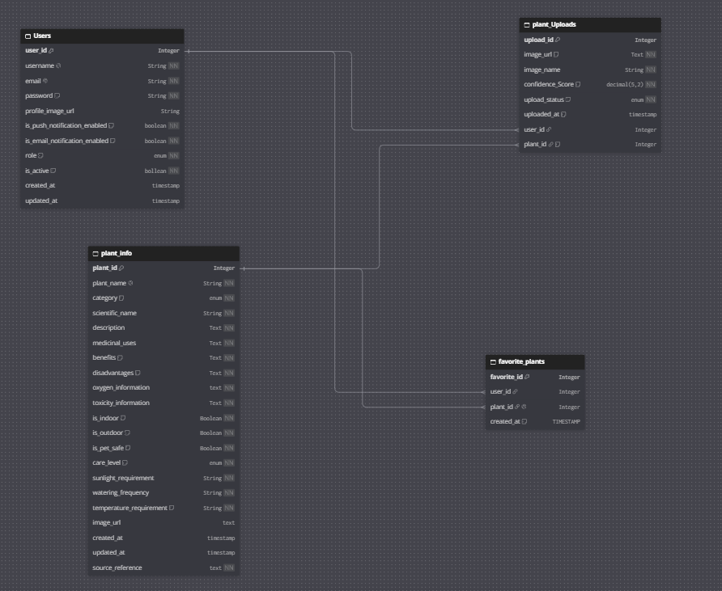
The database diagram provided contains four main tables:
- Users
- Plant_Uploads
- Plant_Info
- Favorite_Plants

  - Table Description
Table Name | Purpose
Users | Stores user account information, credentials, profile image references, notification preferences, roles, account status, and timestamps.
Plant_Info | Stores plant names, scientific names, categories, descriptions, benefits, medicinal uses, toxicity information, care requirements, suitability, and image references.
Plant_Uploads | Stores plant identification upload records, image information, confidence scores, upload status, upload timestamps, and references to the associated user and plant.
Favorite_plants | Stores the relationships between users and their favorite plants, including the date the favorite was created.

  - Table Relationships
Relationship | Type | Explanation
Users → plant_upload | One-to-many | One user can have multiple plant identification uploads. Each upload belongs to a user.
plant_info → plant_uploads | One-to-Many | One plant can be associated with multiple identification uploads. Each upload can reference a plant record.
users → favorite_plants | One-to-Many | One user can save multiple favorite plant records.
plant_info → favorite_plants | One-to-Many | One plant can be favorited by multiple users.
Together, users and plant_info have a many-to-many relationship through favorite_plants. The junction table records which users have favorite which plants.

  - Table Relationships
Table | Key | Purpose
users | userId (Primary Key) | Uniquely identify each user
Plant_info | plantId (Primary Key) | Uniquely identify each plant
Plant_uploads | uploadId (Primary Key) | Uniquely identify each identification upload
Plant_uploads | userId (Foreign Key) | References users.userId
plant_uploads | plantId (Foreign Key) | Reference plant_info.plantId
Favorite_Plants | favoriteId (Primary Key) | Uniquely identify each favorite record
Favorite_plants | userId (Foreign Key) | Reference users.userId
Favorite_plants | plantId (Foreign Key) | References plant)

- System Architecture and Application Workflow
  - System Architecture
Flora-Sense follows a client-server architecture in which the React frontend communicates with a Spring Boot backend through REST APIs. The backend handles business logic, authentication, data persistence, and integration with the external Pl@ntNet plant identification service.
The PostgreSQL database stores structured application data, including user accounts, plant information, favorites, and plant upload records.
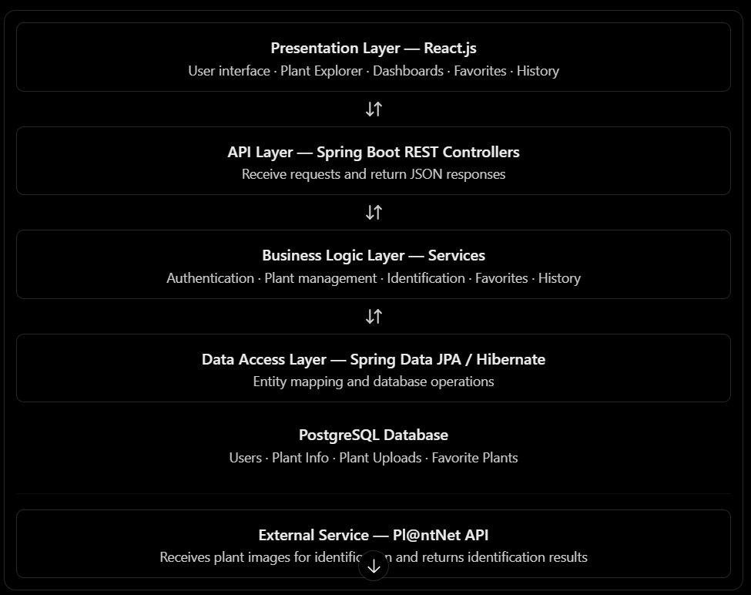
  - Application Workflow
1. User Registration and Login: Users create an account and log in through the authentication APIs. Spring Security protects authorized endpoints using JWT-based authentication.
2. Plant Image Upload: The user uploads or captures a plant image through the React interface.
3. Plant Identification: The Spring Boot backend sends the image to the Pl@ntNet API and processes the returned plant identification result and confidence score.
4. Database Processing: The system associates the identification result with the relevant plant information and stores the upload record in PostgreSQL.
5. Plant Details Display: The frontend displays available plant details, including scientific name, benefits, medicinal uses, toxicity information, pet safety, and indoor or outdoor suitability.
6. Favorites and History: Users can save favorite plants, revisit previous identification results, and manage their identification history.
7. Dashboard and Exploration: Users can view personal activity summaries, recent discoveries, trending plants, and available plant information.
8. Administrative Operations: Administrators can manage users and plant records, view system statistics, and export data.

APIs of User Table
- APIs of Authentication of User
  - Overview:
The User Authentication module manages user registration, login, token refresh, logout, and retrieval of the currently logged-in user's details. It uses Spring Boot REST APIs to handle authentication-related requests and delegates business logic to the AuthService class.
  - API Endpoint Summary:
HTTP Method | Endpoint | Description | Status
POST | /api/auth/register | Register a new user | Done
POST | /api/auth/login | Authenticate a user and log them in | Done
POST | /api/auth/refresh-token | Generate a new access token using a refresh token | Not Done
POST | /api/auth/logout | Log out the currently authenticated user | Not Done
GET | /api/auth/me | Retrieve the currently logged-in user's details | Done

- APIs of User Management / Profile Dashboard
  - Overview:
The User Management / Profile module allows users to view their profile information, retrieve and update notification preferences, delete their account, and upload or delete their profile image. It helps users manage their personal information and customize their account settings within the FloraSense application.
  - API Endpoint Summary
HTTP Method | Endpoint | Description | Status
GET | /api/users/me | Retrieve the currently logged-in user's profile details | Done
GET | /api/users/me/preferences | Retrieve the user's notification preferences | Done
PUT | /api/users/me/update/preferences | Update the user's notification preferences | Done
DELETE | /api/users/me/delete | Delete the currently logged-in user's account by making it disable instead of deleting it physically. | Done
POST | /api/users/me/upload/profile-image | Upload or update the user's profile image | Done
DELETE | /api/users/me/delete/profile-image | Delete the user's profile image | Done

- APIs of Admin Management
  - APIs of User Management by ADMIN
    - Overview:
The Admin User Management module allows administrators to manage and monitor user accounts in the FloraSense application. It provides functionality to retrieve users with pagination and sorting, view individual user details, activate or deactivate accounts, export user data as a CSV file, and view user statistics.
    - API Endpoint Summary
HTTP Method | Endpoint | Description | Status
GET | /api/admin/users/allUsers | Retrieve all users with pagination and sorting | Done
GET | /api/admin/users/user/{userId} | Retrieve a specific user by user ID | Done
PATCH | /api/admin/users/update/  {userId}/status | Activate or deactivate a user account | Done
GET | /api/admin/users/export | Export user data as a CSV file for use in Excel or Google Sheets | Done
GET | /api/admin/users/allUsers/stats | Retrieve user statistics | Done

  - APIs of Plant Management by ADMIN
    - Overview:
The Admin Plant Management module allows administrators to manage plant information in the FloraSense application. It provides functionality to add new plants, retrieve plant details with searching, filtering, sorting, and pagination, update existing plant information, deactivate plants using soft deletion, restore inactive plants, and export plant data as a CSV file for use in Excel or Google Sheets.
    - API Endpoint Summary:
HTTP Method | Endpoint | Description | Status
POST | /api/admin/plants/addNewPlant | Add a new plant to the database | Done
GET | /api/admin/plants/allPlants | Retrieve plant details with searching, filtering, sorting, and pagination | Done
GET | /api/admin/plants/plantId/  {plantId} | Retrieve plant details by plant ID | Done
PUT | /api/admin/plants/updatePlant/  {plantId} | Update existing plant information using the plant ID | Done
DELETE | /api/admin/plants/deletePlant/  {plantId} | Deactivate a plant using soft deletion instead of physically deleting it, preserving related database records | Done
PATCH | /api/admin/plants/{plantId}/  restorePlant | Restore an inactive plant to active status | Done
GET | /api/admin/plants/export | Export plant data as a CSV file for use in Excel or Google Sheets | Done

  - APIs of Admin Dashboard Management by ADMIN
    - Overview:
The Admin Dashboard Management module provides administrators with a centralized overview of the FloraSense application. It retrieves statistics related to users, plants, and plant identification uploads, helping administrators monitor application activity and understand the overall system status.
    - API Endpoint Summary
HTTP Method | Endpoint | Description | Status
GET | /api/admin/dashboard/stats | Retrieve user, plant, and plant upload statistics for the Admin Dashboard | Done

APIs of Favorite Plant Table
- APIs of Favorite Plant Management
  - Overview:
The Favorite Plant Management module allows users to save and manage their favorite plants in the FloraSense application. It provides functionality to add and remove plants from favorites, retrieve favorite plants with searching, filtering, sorting, and pagination, check whether a plant is already favorited, and retrieve the total number of favorite plants. The module also supports displaying the appropriate heart icon on the Plant Details page based on the user's favorite status.
  - API Endpoint Summary
HTTP Method | Endpoint | Description | Status
POST | /api/favorites/addFavoritePlant/  {plantId} | Add a plant to favorites when the user clicks the heart button on the Plant Details page | Done
GET | /api/favorites/allFavoritePlants | Retrieve all favorite plants with searching, filtering, sorting, and pagination | Done
GET | /api/favorites/{plantId}/check | Check whether a plant is already in favorites to display a filled red heart or an outline heart on the Plant Details page | Done
DELETE | /api/favorites/removeFavoritePlant/  {plantId} | Remove a plant from the user's favorites | Done
GET | /api/favorites/count | Retrieve the total number of favorite plants for the current user | Done

APIs of Plant Upload Table
- APIs of Plant Identification using Pl@ntNet API
  - Overview:
The Plant Identification module allows users to upload plant images for identification using the external Pl@ntNet API. The system sends the uploaded image to Pl@ntNet for identification, processes the identification result, and stores the upload information and associated plant details in the PlantUpload table. Users can then retrieve the identified plant details using the corresponding upload ID.
  - API Endpoint Summary
HTTP Method | Endpoint | Description | Status
POST | /api/plant-identification/upload | Upload a plant image, send it to the external Pl@ntNet API for identification, and store the upload information in the PlantUpload table | Done
GET | /api/plant-identification/plantDetails/  {uploadId} | Retrieve plant identification details using the upload ID | Done

- APIs of Plant History Management
  - Overview
The Plant History Management module allows users to view and manage their previous plant identification records in the FloraSense application. It provides functionality to retrieve identification history with searching, sorting, and pagination, view detailed plant information, count total identification records, delete individual history records with conditional image-file cleanup, and export plant history data as a CSV file for use in Excel or Google Sheets.
  - API Endpoint Summary
HTTP Method | Endpoint | Description | Status
GET | /api/plant-history/allPlantCards | Retrieve plant identification history with searching, sorting, and pagination | Done
GET | /api/plant-history/count | Retrieve the total number of plant identification records for the current user | Done
GET | /api/plant-history/plantDetails/  {uploadId} | Retrieve plant details when the user clicks the View Details button on a plant history card | Done
DELETE | /api/plant-history/deletePlantHistory/{uploadId} | Delete a plant history record and remove its image file from local storage if it is not referenced by other uploads | Done
GET | /api/plant-history/export | Export plant identification history as a CSV file for use in Excel or Google Sheets | Done

- APIs of User Dashboard Management
3.1. Overview
The User Dashboard Management module provides users with a personalized overview of their activity in the FloraSense application. It displays summary information such as the username, total plant uploads, favorite plants, and identification accuracy. It also shows the three most recent plant discoveries, allowing users to quickly access their latest identification results.
3.2. API Endpoint Summary
HTTP Method | Endpoint | Description | Status
GET | /api/user-dashboard/summary | Retrieve dashboard summary details, including username, total uploads, favorite plants, and identification accuracy | Done
GET | /api/user-dashboard/recent-discoveries | Retrieving the three most recent plant discoveries for display on the User Dashboard | Done

- APIs of User Trending Dashboard Management
4.1. Overview
The User Trending Dashboard Management module highlights popular plants in the FloraSense application based on successful plant identifications across all users. It provides two main features: a Trending Plants list that displays the top three plants ranked by identification count, and a Featured Plant card that highlights a plant based on its trending rank. The featured plant can rotate daily or weekly to showcase different popular plants and encourage users to discover them.
4.2. API Endpoint Summary
HTTP Method | Endpoint | Description | Status
GET | /api/plants/trending/features | Retrieve the top three trending plants ranked by successful identification counts across all users and the featured plant selected according to the configured rotation logic | Done
a) Trending list(Top 3 plants) :(Count how many successful identifications each plant has received across all users. With rank.
First Maximum Count become 1st Trending Plant
Second Maximum Count becomes 2nd Trending Plant
Third Maximum Count becomes 3rd Trending Plant)
Plant | Successful identifications rank
Snake Plant | 4 1
Chinese Money Plant | 2 2
Fiddle Leaf Fig | 1 3

b) Featured Plant (Top 1 plant): (calculates which plant has the highest number of successful identifications. And this plant becomes Featured Plant. It can feature a different plant every day or every week. i.e change the Featured Plant card on daily basis using the rank of Trending Plant list.
Day Featured plant
Monday Snake Plant — rank 1
Tuesday Chinese Money Plant — rank 2
Wednesday Fiddle Leaf Fig — rank 3

- APIs of Plant Explorer Management
5.1. Overview
The Plant Explorer Management module allows users to explore and discover plants available in the Flora-Sense application. It provides functionality to retrieve all active plants with optional searching and filtering, helping users find plants based on their interests. Users can also view detailed information about an individual plant by selecting its plant card on the Plant Explorer page.

5.2. API Endpoint Summary
HTTP Method | Endpoint | Description | Status
GET | /api/plants/explorer/plantCard | Retrieve all active plants with optional searching and filtering. | Done
GET | /api/plants/explorer/plantDetails/  {plantId} | Retrieve detailed information about a specific plant when the user clicks its card on the Plant Explorer page | Done

- Future Enhancements
Flora-Sense is designed with the possibility of adding more advanced features in future versions. The first version focuses on essential plant identification, plant information management, user accounts, upload history, favorites, and plant exploration. Future versions will aim to provide more intelligent plant care assistance and personalized recommendations.
    - MVP Features – Version 1
The Minimum Viable Product (MVP) includes the core features required to deliver the primary functionality of the Flora-Sense application.
S. No. | Feature | Description | Status
 | User Registration and Login | Allow users and administrators to authenticate and access authorized features. | Implemented
 | Plant CRUD Operations | Allow administrators to add, view, update, deactivate, and restore plant records. | Implemented
 | Plant Image Upload | Allow users to upload or capture plant images for identification. | Implemented
 | Plant Identification API Integration | Integrate the Pl@ntNet API to identify plants from uploaded images. | Implemented
 | Plant Details Display | Display available plant information, benefits, safety details, and care requirements. | Implemented
 | Upload History | Maintain and display users' previous plant identification records. | Implemented
 | Favorite Plants | Allow users to save, view, and remove favorite plants. | Implemented
 | Search and filter | Enable users to search and filter plant information and relevant lists. | Implemented

    - Future Features – Version 2
The following features are planned for future development to enhance the functionality and user experience of Flora-Sense.
S. No. | Feature | Description
 | AI Chatbot for Plant Queries | Provide conversational assistance for plant-related questions, care guidance, and general plant information.
 | Plant Disease Detection | Analyze plant images to identify possible diseases, symptoms, or pest-related problems and suggest appropriate next steps.
 | Plant Recommendation Engine | Recommend plants based on user preferences, available space, lighting conditions, climate, and care requirements.
 | Nearby Plant Nursery Finder | Help users discover nearby plant nurseries and gardening shops using location-based services.
 | Plant Care Reminder Notifications | Send reminders for watering, fertilizing, pruning, and other plant care activities.
 | Plant Growth Tracking | Allow users to record plant growth over time using images, dates, and progress history.
 | External Plant Information Lookup | If a plant is identified but its details are missing from the local database, retrieve additional information from an external provider such as Pl@ntNet API, Plant.id, Trefle, or Perenual, or use a suitable Gemini/OpenAI integration to generate informational responses grounded in reliable sources.
    - Future Enhancement Strategy
Future development will focus on making Flora-Sense more intelligent, personalized, and useful for everyday plant care.
- Improved identification and diagnosis: Extend image-based analysis to identify potential plant diseases and other visible problems.
- Intelligent assistance: Introduce an AI chatbot that answers plant-related questions and provides context-aware guidance.
- Personalized recommendations: Suggest plants that match the user's environment, preferences, and care capabilities.
- Automated care management: Introduce reminders and growth tracking to help users maintain healthy plants.
- Expanded plant knowledge: Retrieve missing plant information from external sources when a plant record is unavailable or incomplete in the local database.
External information will need appropriate validation and source attribution. Medicinal claims and toxicity guidance should be presented cautiously and supported by reliable references rather than generated or accepted without verification.
Q1. Which plant identification model or API can be used in this application?
For the Flora-Sense – Plant Care & Detection System, we can integrate an existing plant identification API or use an open-source AI model instead of developing and training a machine learning model from scratch.

Pl@ntNet API
Pl@ntNet is a plant identification platform that analyzes plant images and returns likely species matches, identification scores, and botanical information where available. It provides a REST API that can be integrated with a Spring Boot backend.
Integration approach:
- The user uploads a plant image through the React frontend.
- The Spring Boot backend sends the image to the Pl@ntNet API.
- The API returns likely plant species and identification scores.
- The backend matches the identified plant with the PlantInfo table in PostgreSQL.
- The application displays the available plant details on the user interface.
Advantages of Pl@ntNet API
- It provides a ready-made plant identification service, eliminating the need to train a model from scratch.
- It supports submitting multiple images of the same plant in a single identification request, subject to API limits.
- It returns scientific names and may provide common names where available.
- It can be integrated into a Spring Boot application using HTTP requests.
Limitations of Pl@ntNet API
- Identification accuracy depends on image quality, the plant species, and the available information in the identification service.
- Some plant species may not be recognized correctly.
- API usage quotas apply. The daily request limit depends on the account and service terms; exceeding the quota may result in HTTP 429 Too Many Requests.
- Network problems or service outages may cause identification requests to fail.
Important note: Pl@ntNet identifies likely plant species, but FloraSense uses its own PlantInfo database to provide application-specific information such as watering frequency, sunlight requirements, pet safety, care level, medicinal uses, and toxicity information. These details should not be assumed to come directly from Pl@ntNet.

Q2. How can you explain the Pl@ntNet integration during a project interview?
In my FloraSense project, I integrated the Pl@ntNet API to identify plant species from images uploaded by users. Developing a plant identification model from scratch would require a large, labeled dataset, machine learning expertise, and ongoing model maintenance. Therefore, I chose an existing identification service to reduce development effort and focus on the application's core functionality.
I integrated Pl@ntNet with my Spring Boot backend. When a user uploads an image, the backend sends it to the external API and receives the likely plant species along with identification scores. The application then matches the identification result with the PlantInfo table in PostgreSQL and displays relevant information, including scientific names, sunlight requirements, watering frequency, care level, and pet safety.
If the identified plant is not available in the local database, the application can handle that situation separately instead of displaying unrelated or incorrect care information.
This integration allowed me to focus on other important features, such as plant identification history, favorites, plant exploration, and personalized dashboards. I also considered potential challenges such as low-confidence results, API failures, and request quotas.
Q3. How do you configure the Pl@ntNet API in application.yaml?
The API configuration can be defined in the Spring Boot application.yaml file.
plantnet:
api:
url:https://my-api.plantnet.org/v2/identify
key: ${PLANTNET_API_KEY}
project:${PLANTNET_PROJECT:all}
Explanation:
- url: The Pl@ntNet API endpoint used for plant identification.
- key: Reads the API key from an environment variable instead of hardcoding the secret in the configuration file.
- project: Specifies the Pl@ntNet identification project. The default value is all if no environment variable is provided.

How to configure the API key in IntelliJ IDEA
- Obtain an API key through the Pl@ntNet developer platform.
- Open your project in IntelliJ IDEA.
- Open Run → Edit Configurations.
- Select your Spring Boot run configuration.
- Open the environment variables section.
- Add the following variables:
PLANTNET_API_KEY=your_actual_api_key
PLANTNET_PROJECT=all
7. Save the configuration and restart the application.
Security recommendation: Never commit your real API key to GitHub or expose it in the React frontend. Keep it in environment variables or a secure secret-management system.
Q4. What were the most challenging parts of your project?
1. Displaying identified plant details on the UI
One challenge was connecting the plant identification result with the correct plant information and displaying it on the front end. I needed to ensure that the identified species matched the appropriate database record so that users received relevant plant details.
2. Integrating the external Pl@ntNet API
Integrating the external API required handling image uploads, sending requests from Spring Boot, processing the identification response, extracting the plant name and confidence score, and managing errors such as unsuccessful identification, network failures, and API quota limits.
3. Deleting plant history and managing image files
Another challenge was implementing the plant history deletion feature. When a user deletes an identification history record, the corresponding database record must be deleted, and the associated image file should be removed from local storage only if no other upload records reference that file.
This required checking image references before deleting a physical file to avoid breaking other upload records.

Step | Module | API | Status
1 | Authentication | Register, Login, JWT | ✅ Completed
2 | User Profile | View profile, update profile, preferences | ✅ Completed
3 | Admin User Management | Manage users, roles, status | ✅ Completed
4 | Admin Plant Management | Add, update, delete, search plants | ✅ Completed
5 | Favorites | Add, remove, list favorites | ✅ Completed
6 | Plant Identification | Upload image and identify using Pl@ntNet | ✅ Completed
7 | Plant Details | Retrieve details using uploadId | ✅ Completed
8 | Plant Identification History | View previous uploads | ✅ Completed
9 | User Dashboard | Total uploads, successful identifications, favorites | After History
10 | React Integration | Connect all pages to backend APIs | Next major phase
11 | Testing and Deployment | Test APIs, security, and deploy application | Final phase

